User Manual

SHOES Shopping .

|  |  |
| --- | --- |
| INDEX | |
| INTRO ABOUT THE WEBSITE | 3 |
| PAGE OVERVIEW | 4 |
| CREATE A ACCOUT | 7 |
| LOGIN | 8 |
| PRODUCT PAGE | 9 |
| CART | 10 |
| CHECKOUT | 11 |
| USER SYSTEM REQUIREMENTS | 12 |

**WHY SHOES?**

Shoes are an essential aspect of every outfit, allowing you to instantly transform from business casual to a fun night out. From mountains to sports to the red carpet to underground mining, the market today offers a dizzying array of footwear in a dizzying array of styles. A decent pair of shoes will always hold its worth. No of the event, appropriate footwear is always required. Many people today prefer to buy shoes online rather than in-store. As a result, nevon projects has developed a python-based platform for effortless and effective online shoe buying. There is a wide variety of shoes for both women and men available at reasonable prices on this online shoe store. Therefore, the availability of online shoe shopping will bring relief to people by allowing them to shop for shoes from the comfort of their own homes. The Admin and Customer sections of our e-commerce platform are where the real action happens. Shoes can be added, items can be seen, customers can be viewed, and orders placed by consumers may be viewed by the administrator. Users may sign up for an account and log in using their credentials. The customer may browse goods, put items in their shopping basket, and complete the purchase; they can also check the status of their order and look back at their purchase history.

**FOR WHAT?**

SHOES, a system that takes measurements of users' feet and makes fitting recommendations, was created so that people may shop for shoes online with confidence and ease. The hardware component is a high-tech scale (weight scale) with an integrated app for use on a smartphone or tablet. The idea behind this method is to provide people with a selection of suitable footwear from which to choose. In-depth user interviews were performed to learn about the consumers' biggest pain points, lifestyles, and hopes for the system when it comes to buying shoes online. Both a hardware and software prototype were tested and found to be appealing after being informed by interviews and data analysis.

Home page

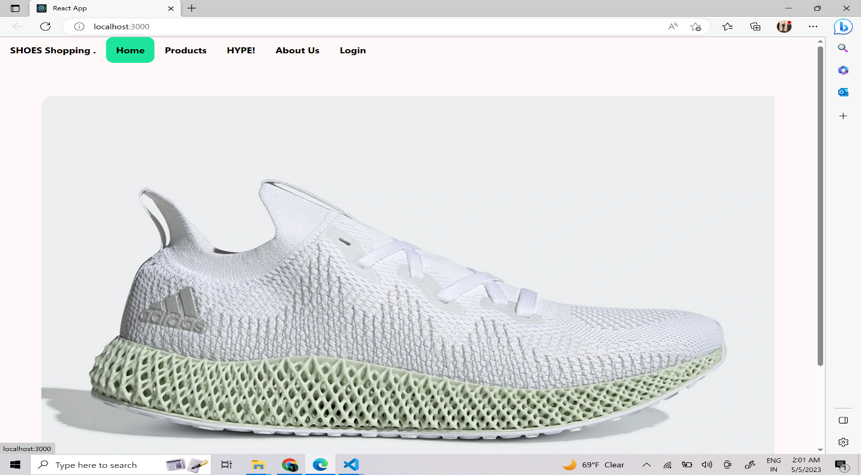

Product page

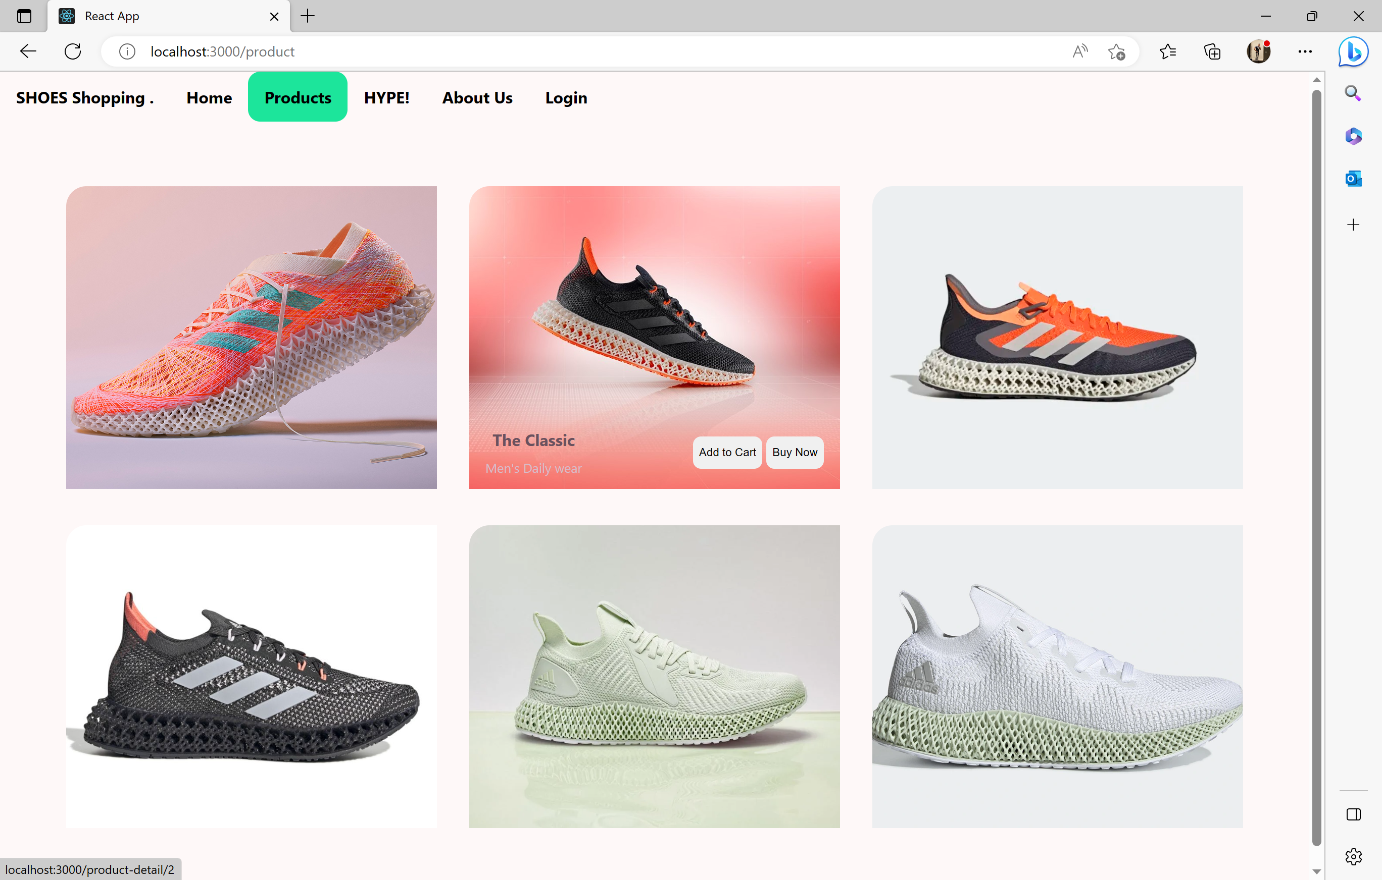

Product page

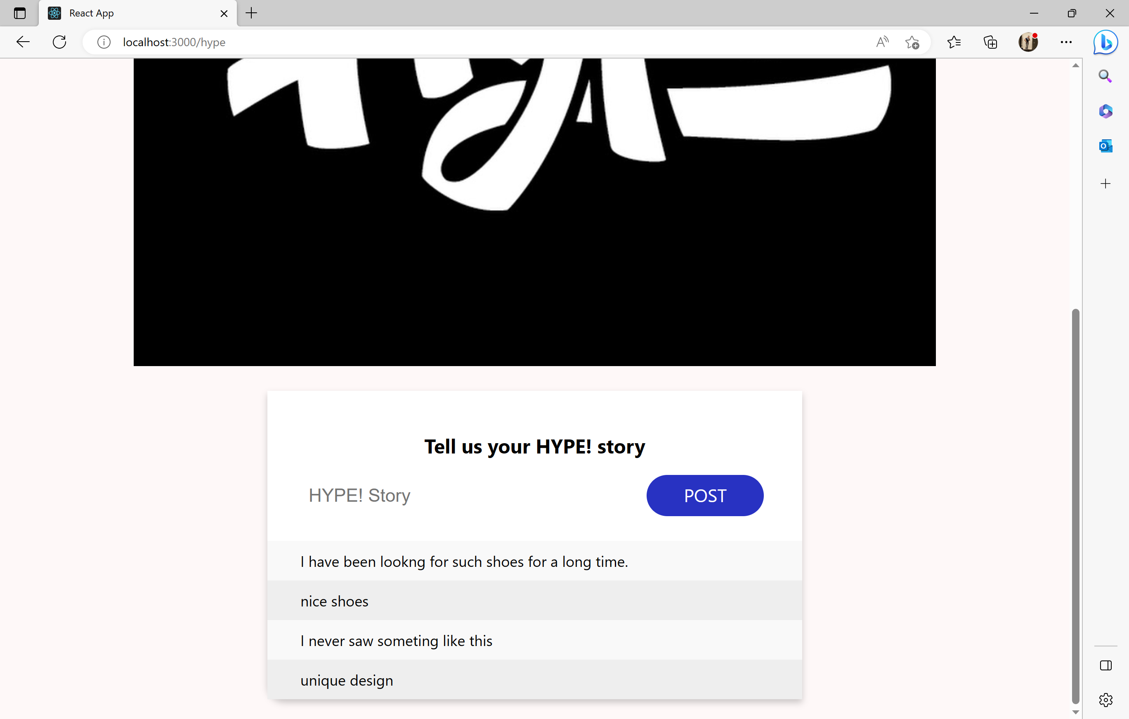

About Us page

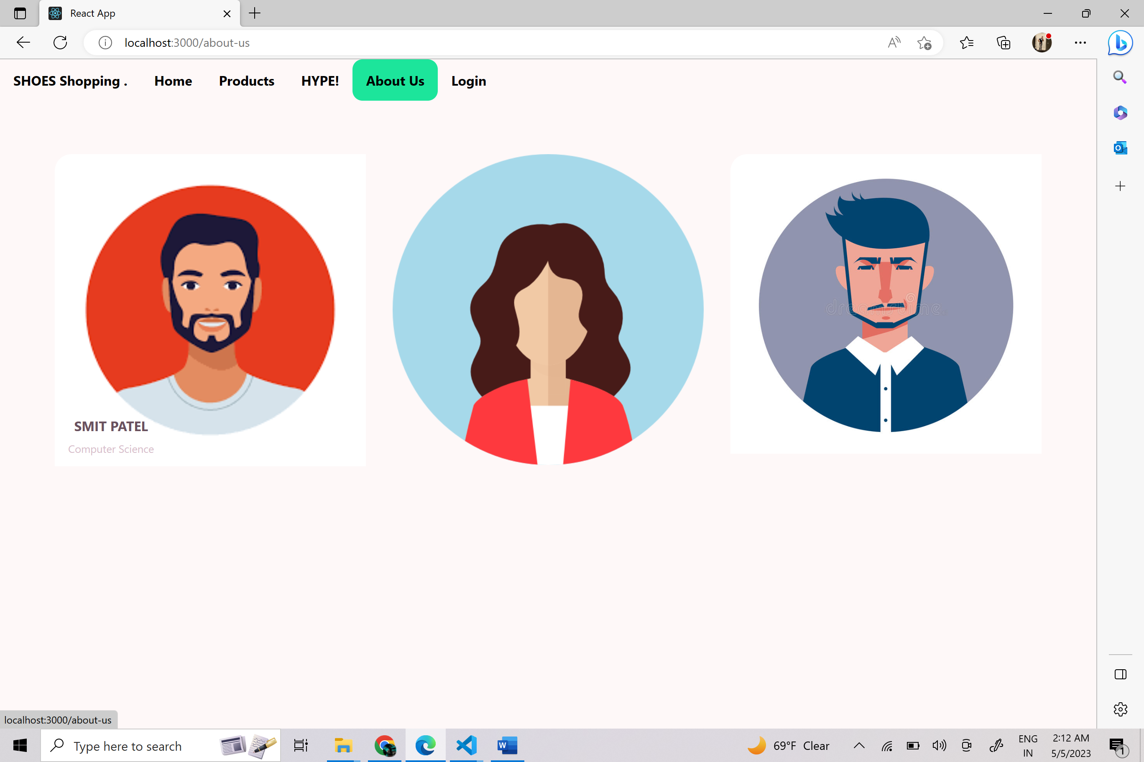

Login or Signup page

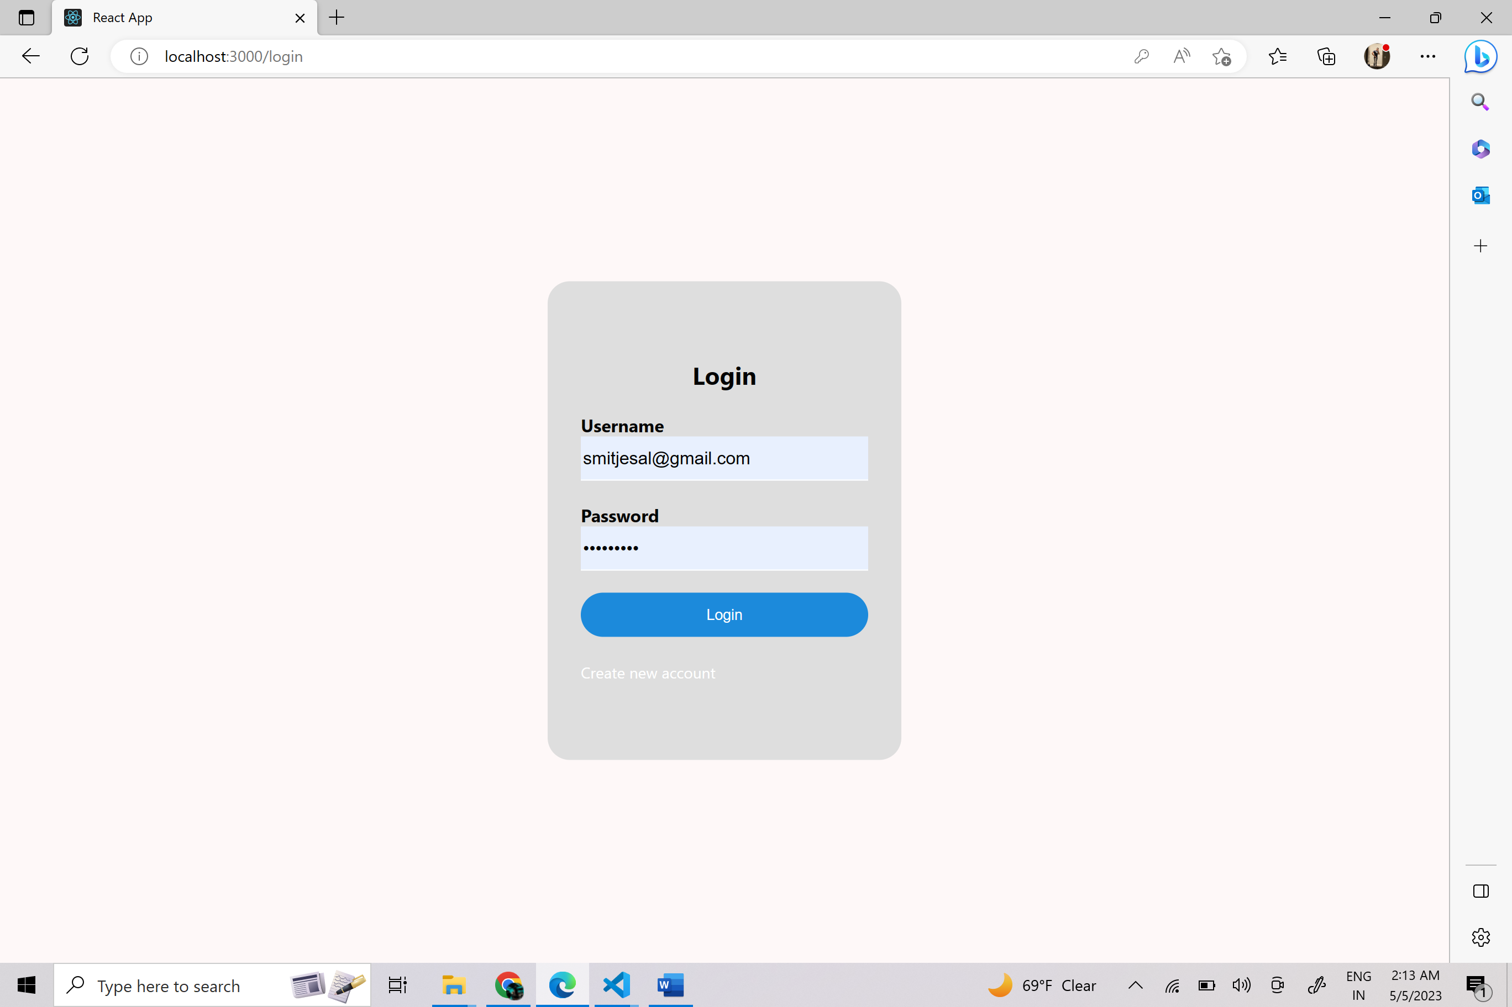 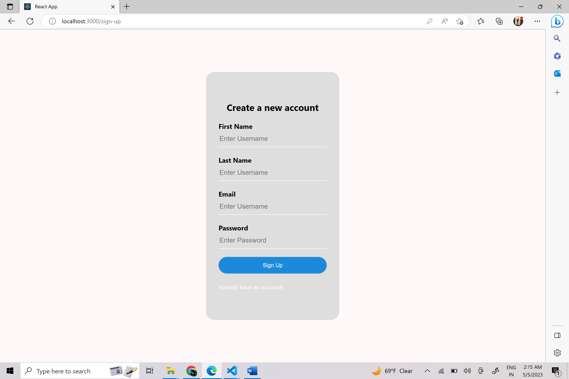

Create a new account



1. First Name: simple name with just Text.
2. Last Name: simple Last name with just Text.
3. Email: User Email ID.
4. Password: Your selected password with
   1. At least One lowercase letter
   2. At least One Uppercase letter
   3. At least One sepcial character
   4. At least One number
   5. Should be more then 8 characters

Login Page

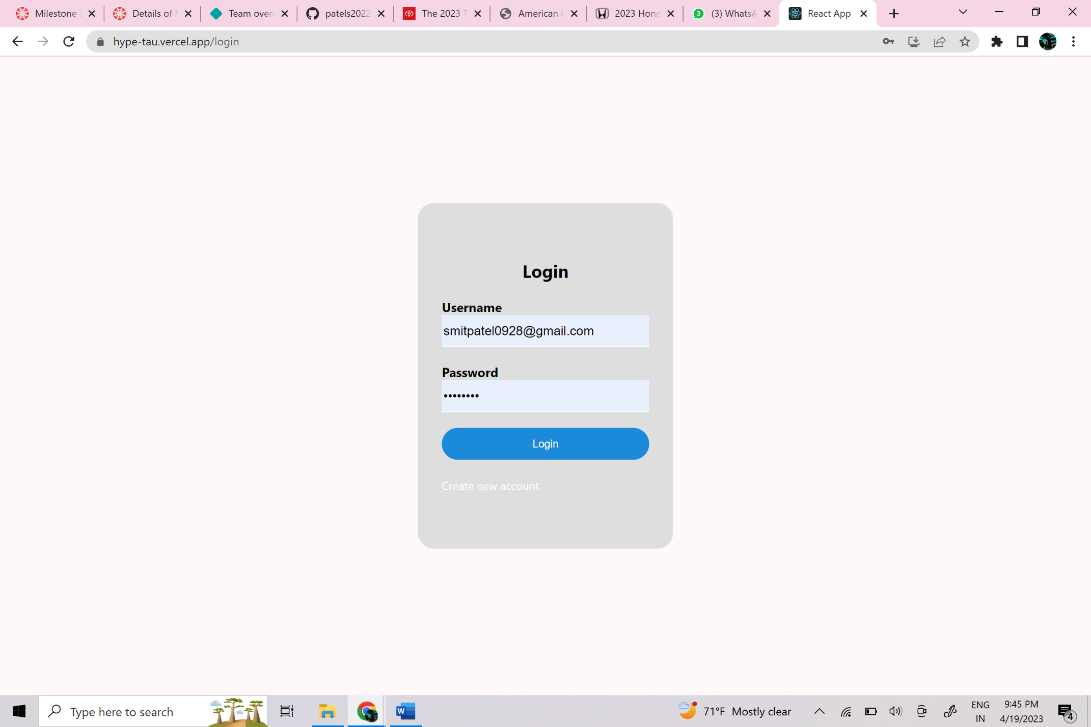

* Login page to log in to the website

1. Username: User email ID given while Creating a new account.
2. Password: User Password given while Creating a new account.
   1. But should validate
   2. At least One lowercase letter
   3. At least One Uppercase letter
   4. At least One sepcial character
   5. At least One number
   6. Should be more then 8 characters

Product Page

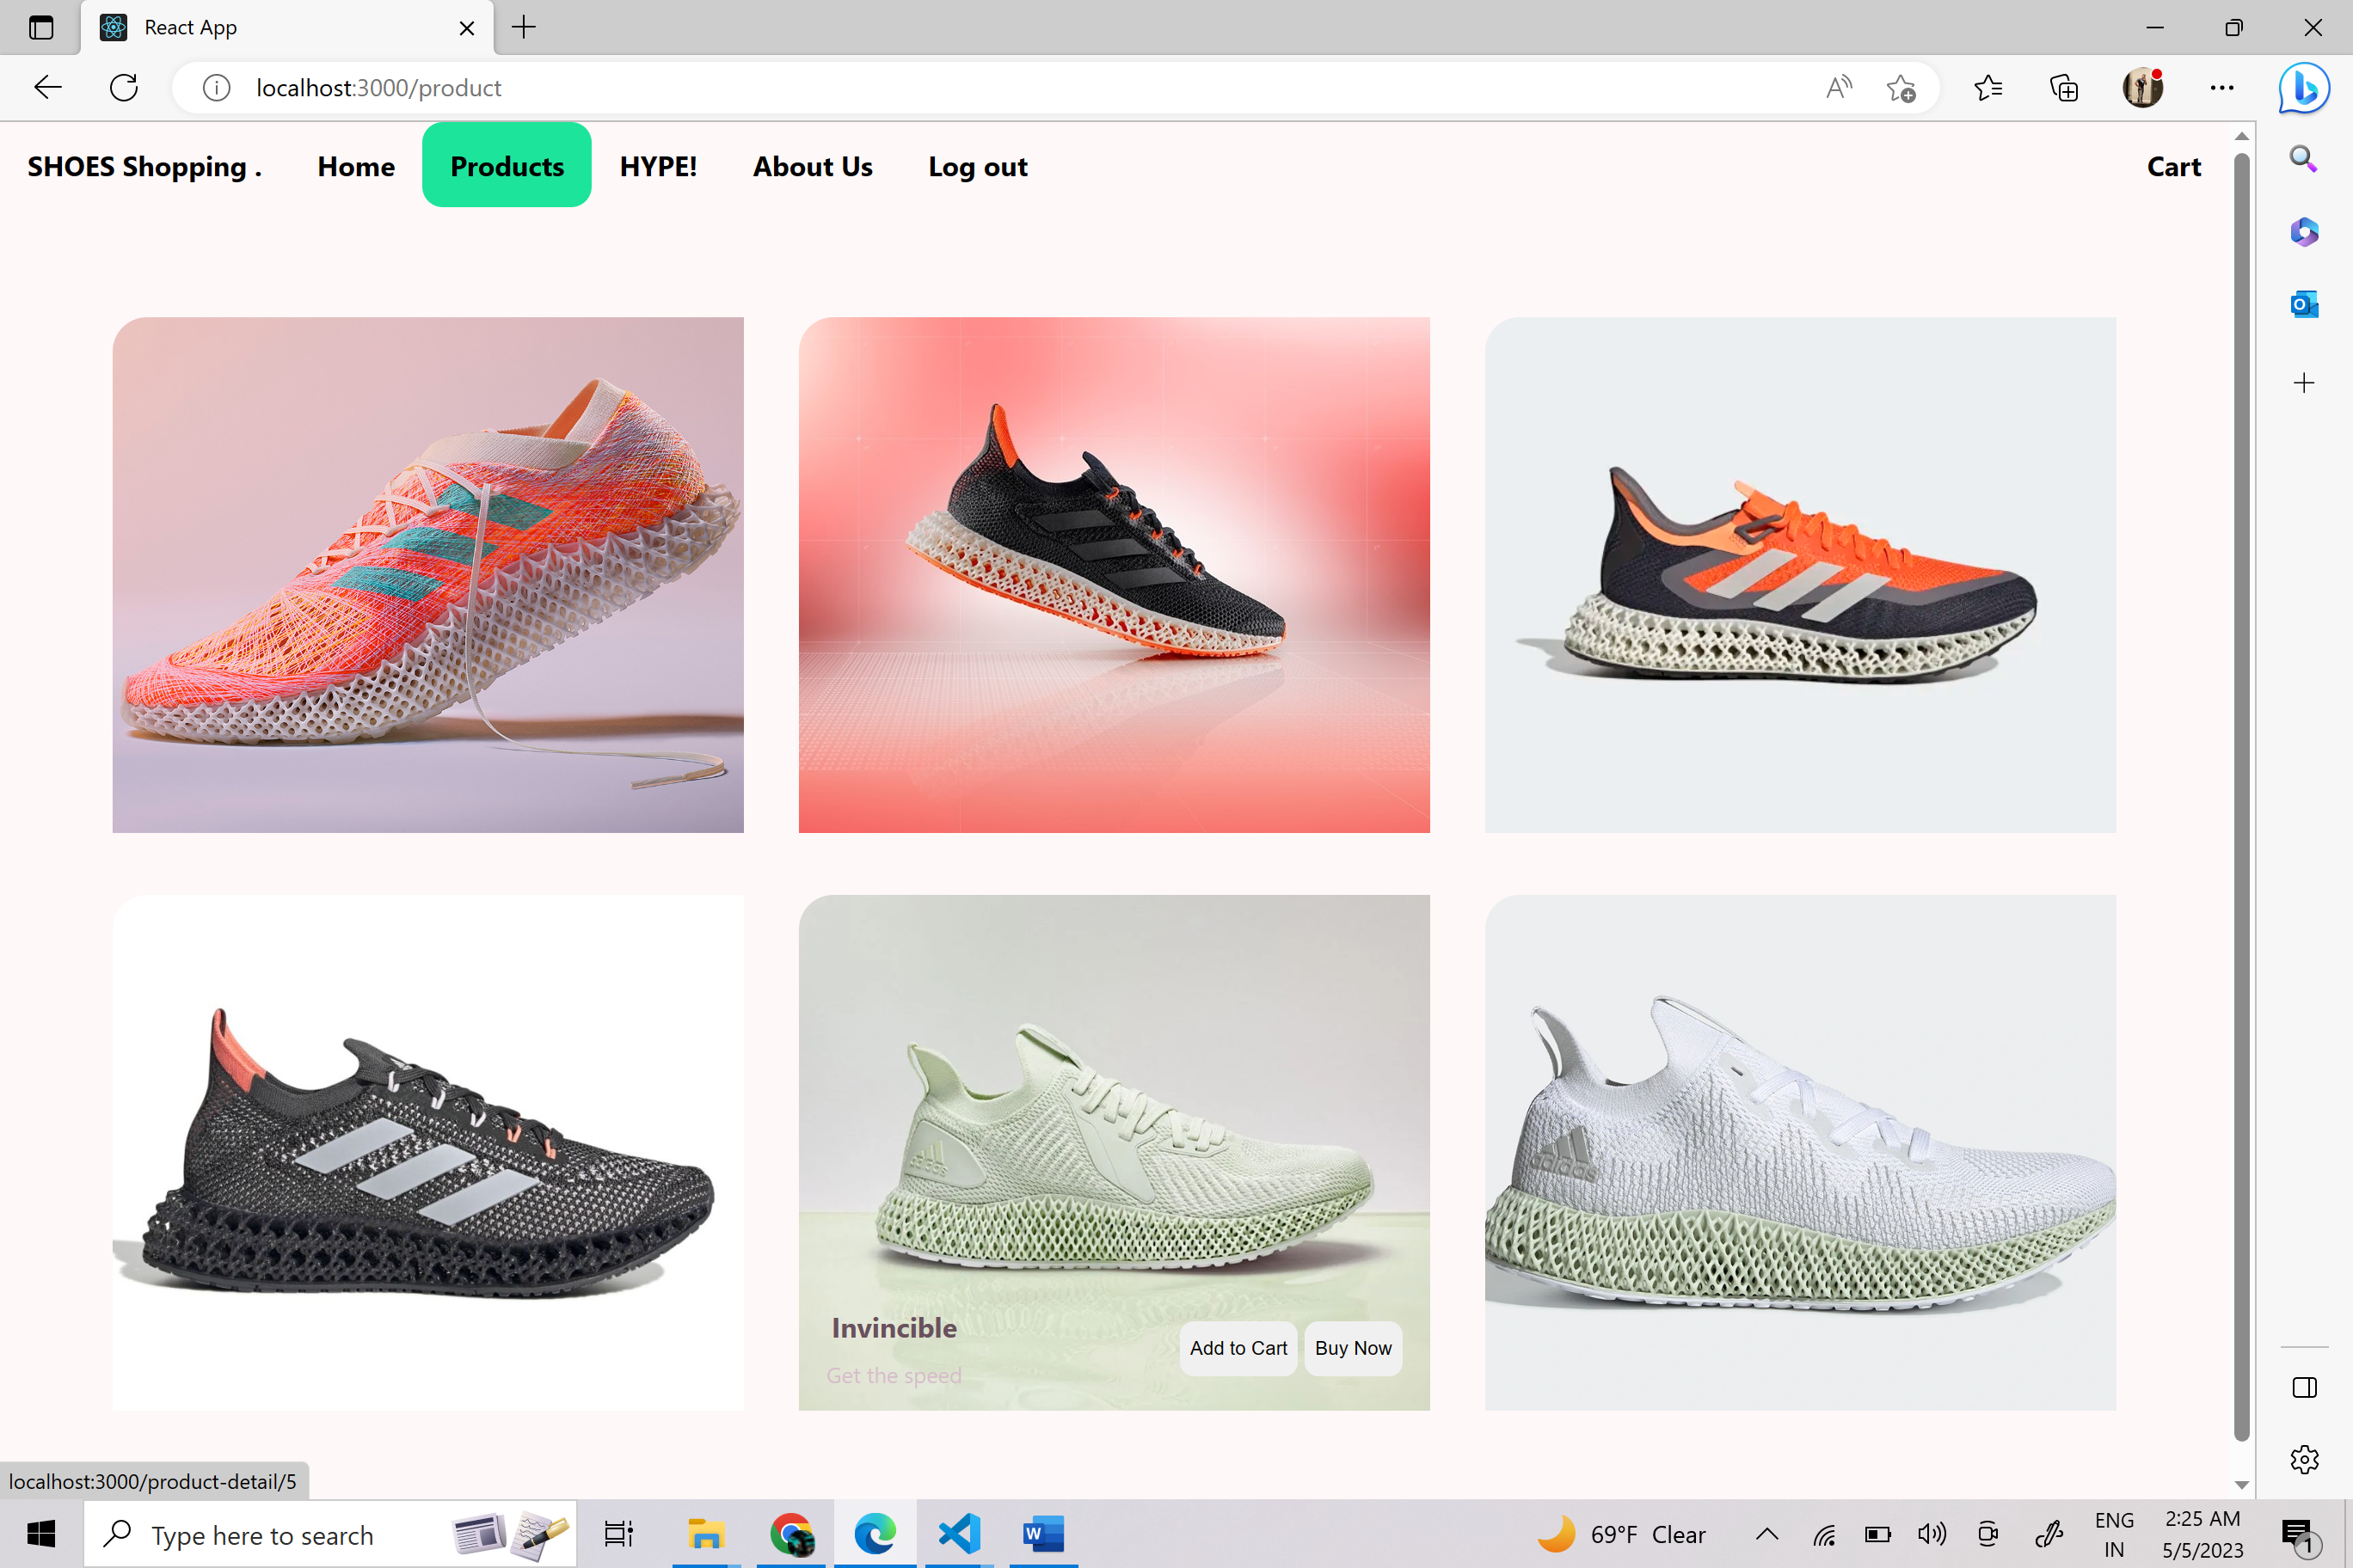

User gets 3 options to chose from

1. Add to cart: It will add this item to your cart.
2. Buy Now: IT will take you to check out page.
3. Product description: select the image and it will give you description about the products

Cart

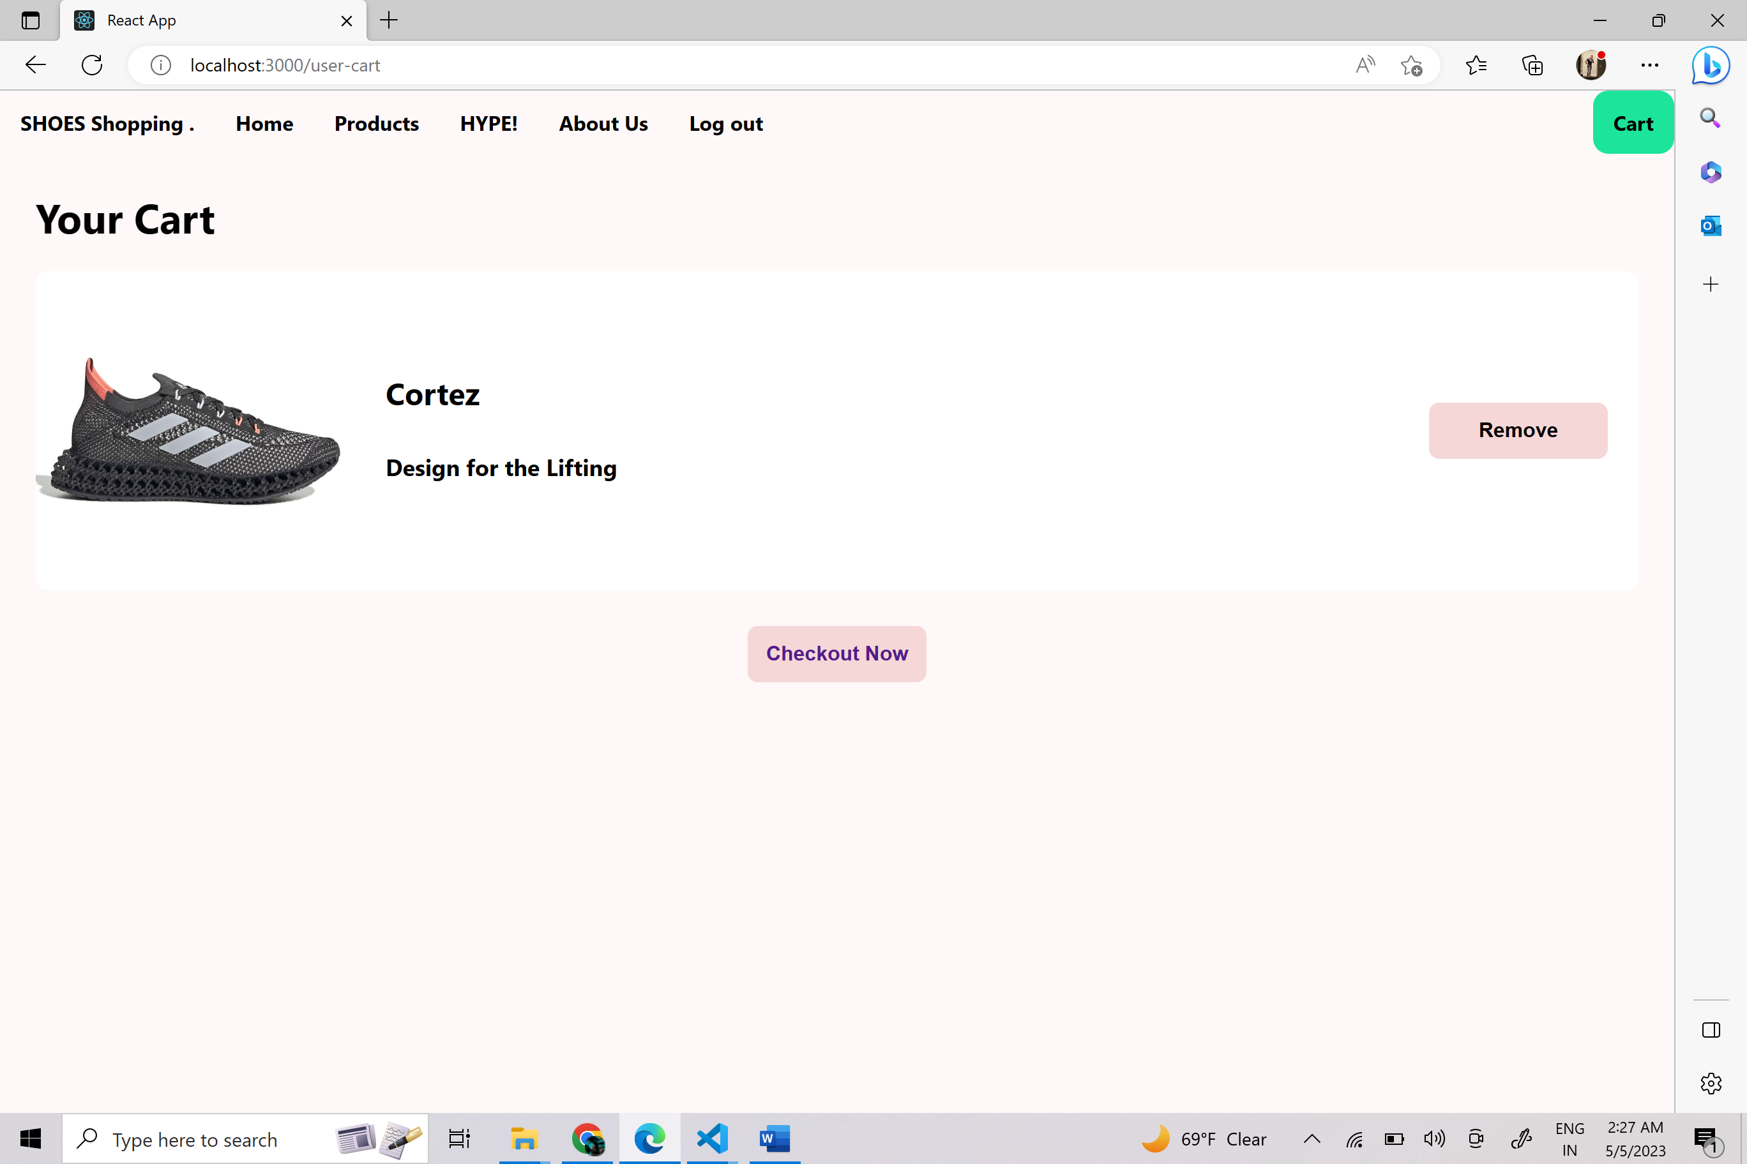

The Cart will show all the product which you add to cart from product page

It give you 2 options.

1. Remove: To remove product from cart.
2. Checkout Now: To continue to check out.

Check out

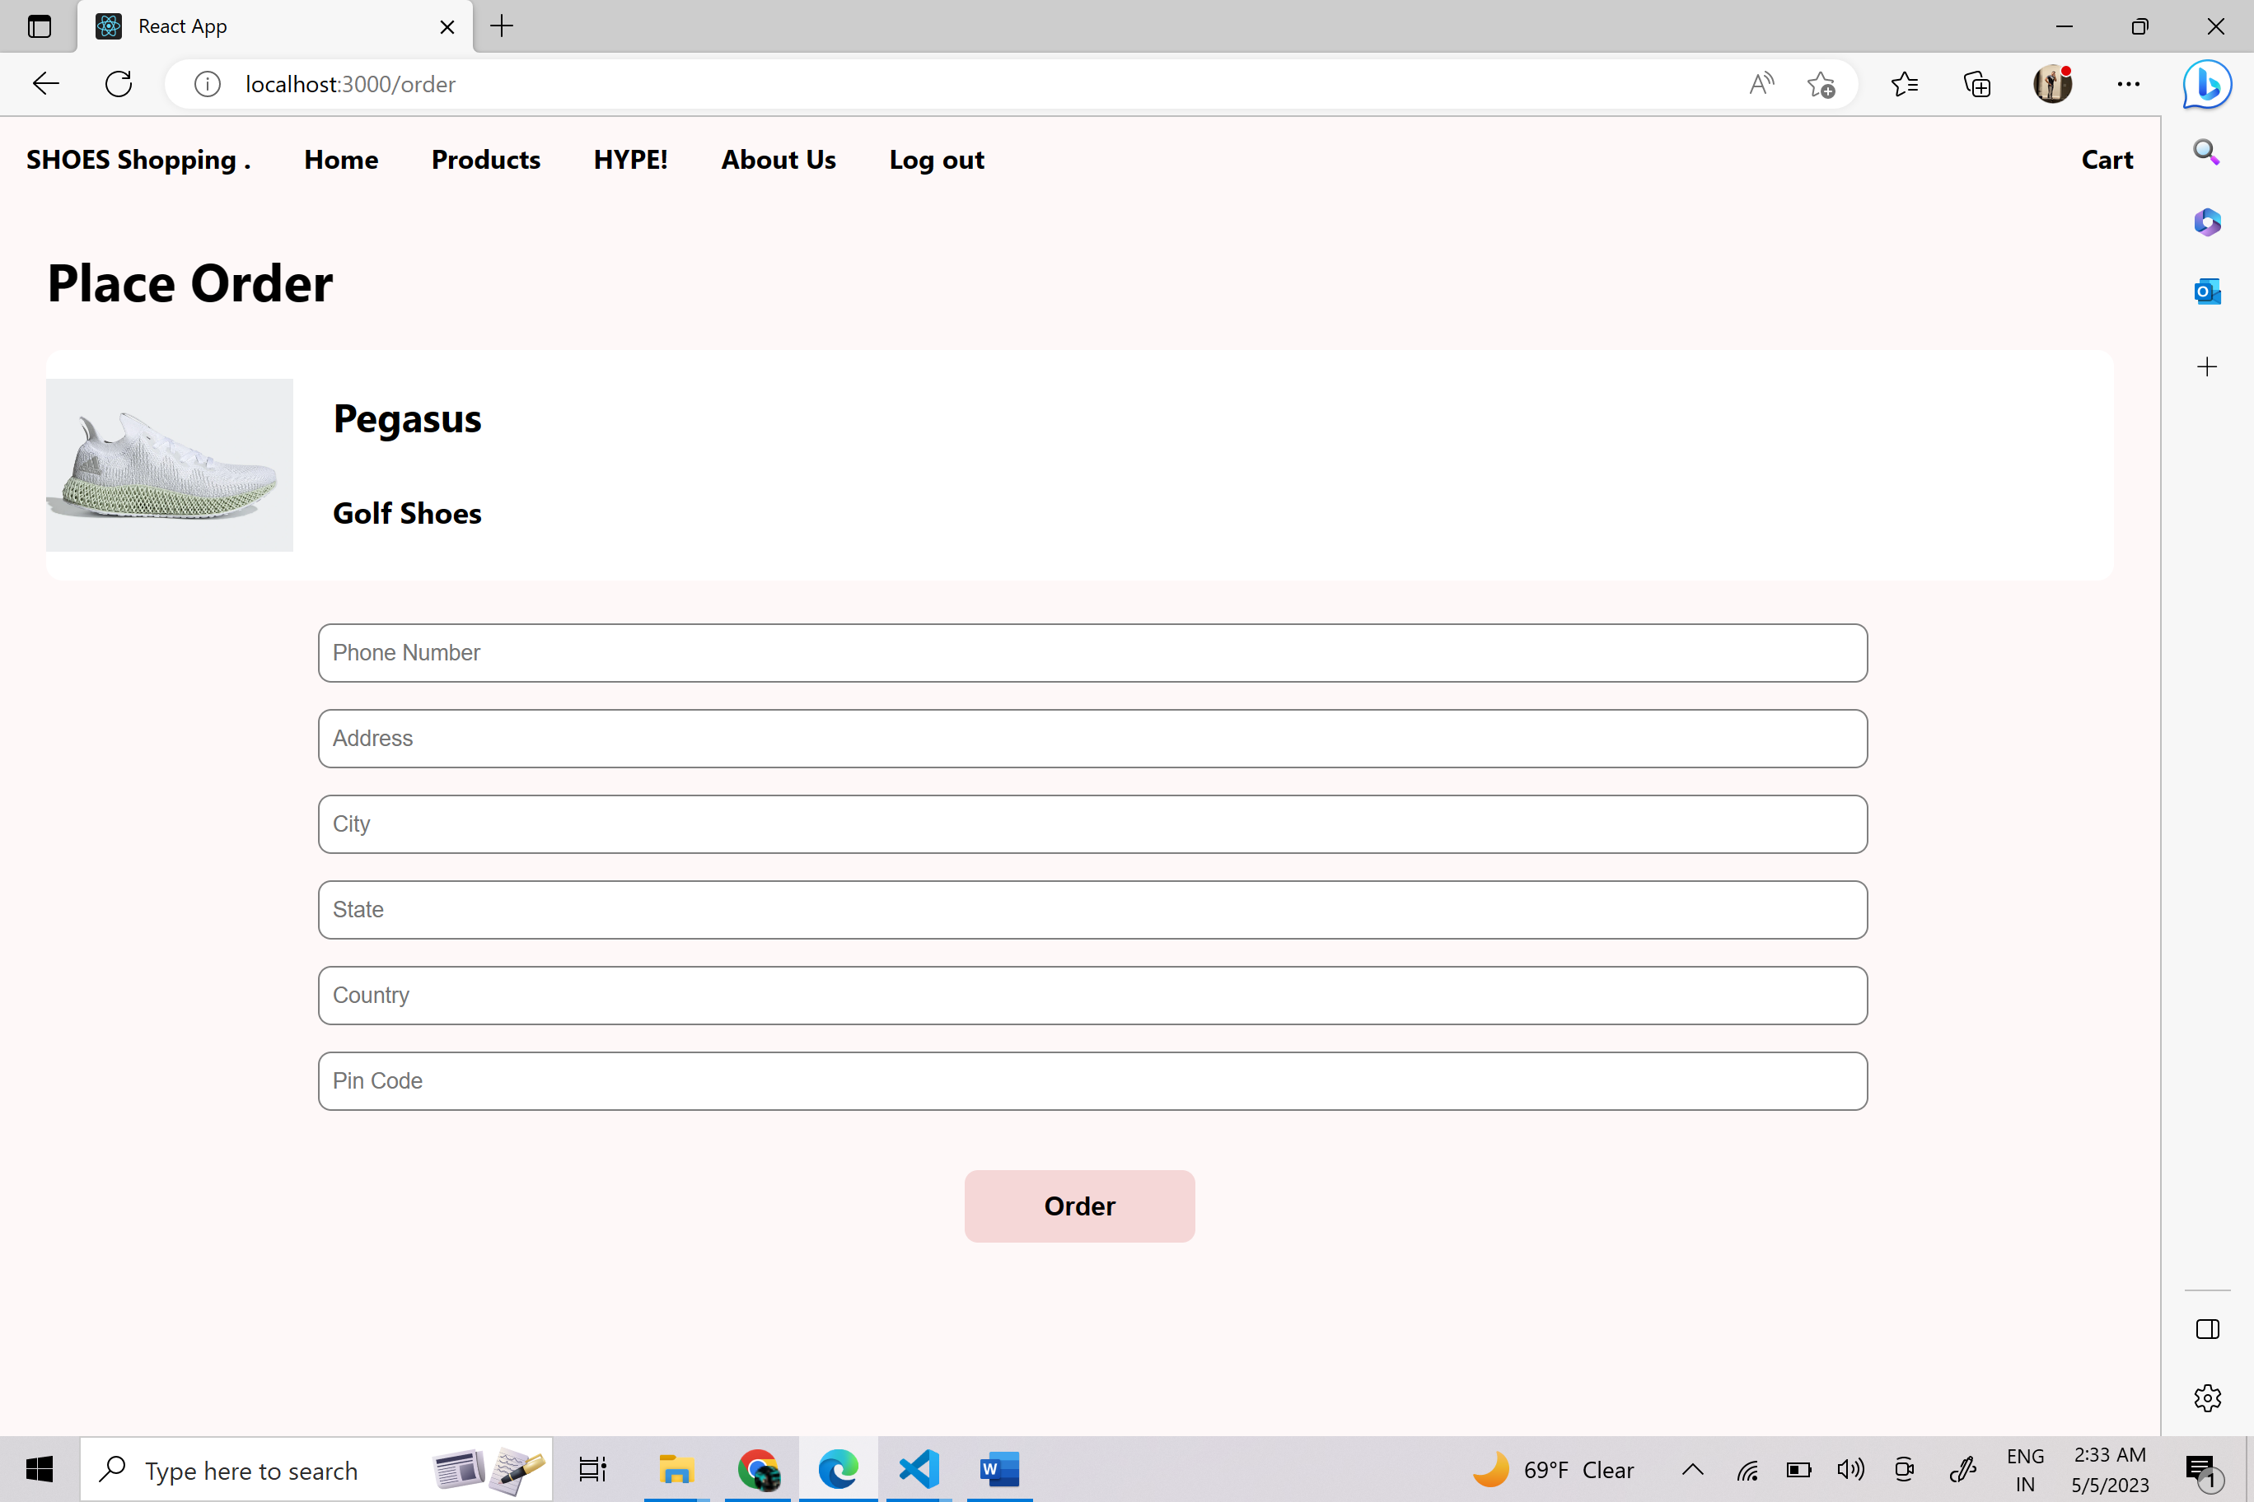

Check out page allow you to order you product.

It show you the product you are ordering

It ask you to fill the textbox neccesary to place order

1. Phone number
2. Address
3. City
4. State
5. County
6. Pincode

User System Requirements

* **Software Requirement:**
* Windows 7 or higher
* React js
* mongo DB framework
* Node js
* Processor –Core i3
* Hard Disk – 160 GB
* Memory – 1GB RAM
* Monitor